Guth na nDaltaí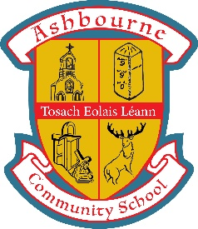

January-February 2021

STUDENT VOICE NEWSLETTER

January-February 2021

*This month the newsletter*

**Amy Spratt Fundraising for Aoife's Clown Doctors**

A great article appeared on the 5th of January 2021 in the Meath Chronicle featuring ACS 3rd year student Amy Spratt and her fantastic fundraising in November 2020 for Aoife's Clown Doctors Ireland. Amy did 10000 Kickups across the month of November to raise over €2500 for the charity. Amy also featured in the ACS interview on Meath Daily TV in December 2020. We are so proud of Amy, as are her soccer club Ashbourne United F.C.

**A message from Head Students**

Firstly, we would like to take the opportunity to congratulate everyone on another great term at ACS.

Everyone has made a great effort to engage with their online classes and teachers and we hope we will return to school soon when it is safe to do so.

We held our 3rd Guth na nDaltaí meeting on Tuesday the 9th of February which took place online. We discussed how students thought their online experience could be improved. We also brought forward proposals for new PE uniforms in the future. Some excellent ideas were brought forward, and we would like to thank all the students for attending.

We hope everyone and their families are healthy and well and best of luck with the next term of school. We look forward to seeing you soon.

*Thanks to Sally in the Meath Chronicle for taking the time to speak to Amy and her family.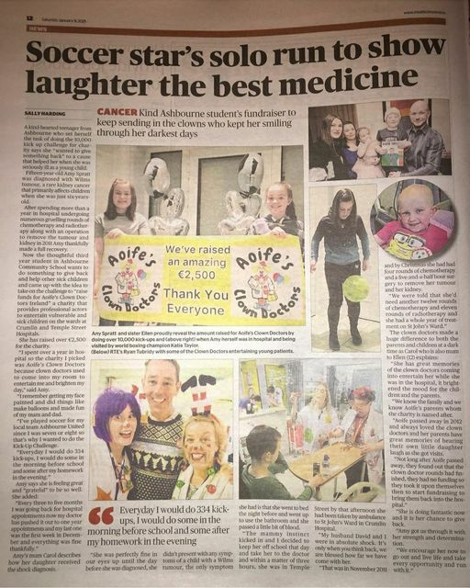*

***This edition is edited by TY Journalists.***

**Tom O'Hara Fundraising for the Irish Cancer Society**

Congratulations to TY student Tom O'Hara on his €1465 final total for his ACS TY Relay Marathon Event, which was held on Thursday 10th December 2020 in aid of the Irish Cancer Society. Thanks to all the TYs and staff who took part or helped on the day.

Thanks to all who donated also. #fundraising

----------------------------------------------------------------------------------------

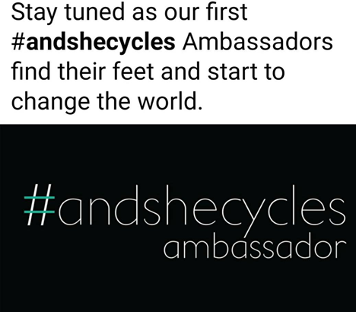

**#andshecycles Ambassadors**

**Thanks to TY student, Laura Bolster for this article for the #andshecycles programme.** Today 3 TY girls began their journey to become #andshecycles Ambassadors.

On Thursday the 28th of January 2021, TY girls, Laura Bolster, Aoife White and Mollie White participated in a two and a half hour long meeting for the #andshecycles Ambassador Programme. This usually takes place in person but given the circumstances it took place online. The programme is about helping young girls become more confident in themselves when it comes to cycling to school. It also addresses why so many young girls may feel reluctant to cycle in the first place, and why there is a stigma against girls cycling to school. The programme aims to tackle this and come up with an appropriate solution. It takes place from now until September 2021 and we will be talking part in many actions along the way. The three main objectives are: to develop young role models and leaders for school cycling amongst teenage girls; to empower teenage girls to shape the cycle friendliness of their schools; and to provide opportunities for teenage girls to cycle. Thanks to Ms Hughes for supporting us in this programme. We hope to continue what Cate Cooney, now 6th year, was a huge part of when she was in TY and represent ACS proudly at national level.



**Zeeko Internet Safety Workshop**

**Thanks to Ava Carroll, TY Journalist for this article on the TY Zeeko Internet Safety Workshop.**

On Monday 18th of January 2021, TYs attended a ‘Zeeko Internet Safety Workshop’. Zeeko is an Irish company, and their aims are to teach internet safety to students, teachers, and adults. Due to current restrictions, we must resort to technology and the internet to assist our learning and teaching. So this workshop was very topical and informative about how to stay safe online. The workshop covered 5 main areas; cyber-bullying, inappropriate content, stranger danger, digital footprint, and social media. A digital footprint is a trail of data made when using the internet. It includes your searches, texts, emails, photos, etc. The facilitator from Zeeko also gave us some tips on staying safe online and how to protect ourselves, e.g. not using your face as your profile picture, not using your full name on social media, etc. We were told to always stop and think before sending a text, or putting something online, as it’s then there forever. It was interesting to see how much the internet can affect your life, and how early your digital footprint can start, from late primary school. We were alerted to online bullying and a new law to ban online harassment. ‘Coco’s Law’, in memory of a 21-year-old girl Nicole, who took her own life after she was bullied on social media, from early February 2021 will ban cyberbullying and stalking, and sharing of revenge images online without consent. Although hard hitting in parts, this talk was informative, educational and gave us valuable lessons to carry forward. Thank you to Zeeko for facilitating this workshop.

***Written by, Ava Carroll, TY Journalist***

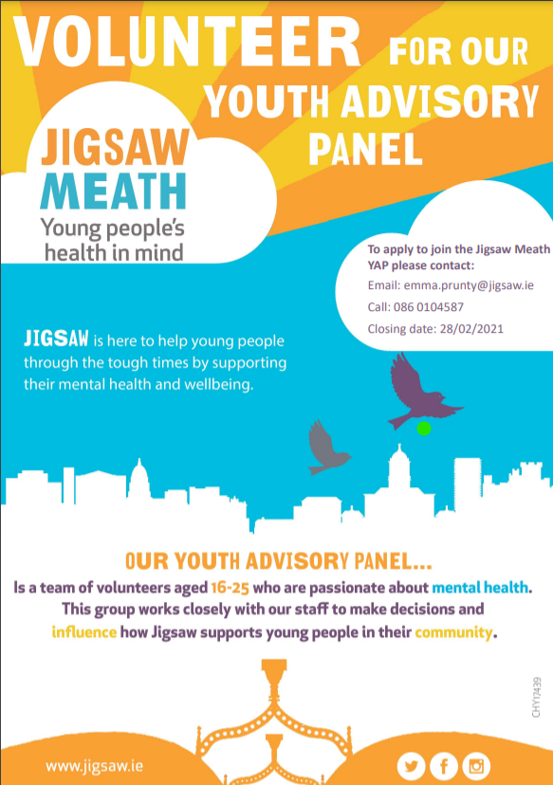

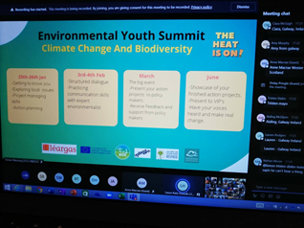

**Environmental Youth Summit**

Well done to our TY students, Róisín Moss, Leo Feeney, Niall Moran, Emily Dunne, Rhys Dagger and Ava Carroll who represented ACS on Monday 25th January 2021, at the Environmental Youth Summit, virtually. The students networked and made new friends from around the country, as well as Scotland and Catalonia. 92 participants engaged with climate change and biodiversity as the key themes of "The Heat Is On" conference. This is day one of several meetings, leading up to the key event in March 2021. We look forward to seeing the results from this incredible event. Thanks to Ms Hughes for the info and photo, and as always for creating great opportunities for our students, particularly TYs. [#green](https://www.facebook.com/hashtag/green?__eep__=6&__cft__%5b0%5d=AZXtLEM3BBDyY4QKlA10wmuTARopR2RKYvCyn7Kksw38ZC1_IJn5lc1jt6BCsr6SH_HXF6kmTpaKlSwI7smQLub8W0VS7yi9dh1vP5kglGyB9QH2gG3k6piAkBKqYFb9646W9zd39Iu4XOdE8OuvYUuzPhKUWc-SM_qcKsZEoyzkn6qP_92Jk1BFv2-7ZYi-380&__tn__=*NK-R)

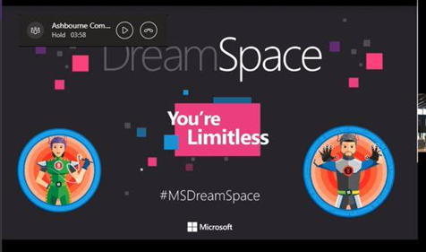

**MS DreamSpace Virtual Workshop**

**Thanks to TY journalist, Adam Muldoon, for this article on the recent TY Microsoft DreamSpace Virtual Field Trip Workshop.**

TY students took part in an online workshop with Microsoft DreamSpace on Monday 11th January 2021. Deciding what you want to do with your life is a daunting task, especially when you are 15 or 16 years old. DreamSpace exists to fire the imaginations of students on what the answer to that question might possibly be. It aims to provide students with immersive STEM experiences and see how STEM is a part of many areas of everyday life, from arts and design to sport and music. The workshop was presented by 2 of the workers from Microsoft’s Branch in Dublin. We got an online tour of the campus and what facilities are there for staff, a breakdown on what Microsoft does and how they have adapted since Covid 19, as well as an introduction to coding and STEM in general. STEM is the idea of educating students in 4 specific disciplines — science, technology, engineering, and mathematics — in an interdisciplinary and applied approach. We learned about Artificial Intelligence (AI) which is the simulation of human intelligence in machines that are programmed to think like humans and mimic their actions. AI can also be applied to any machine that exhibits traits associated with a human mind, such as learning and problem-solving. The workshop sparked students’ creativity to imagine the future and the role that technology may play in changing our lives. DreamSpace provided some brainstorming questions and resources to kick-start this. It was an enjoyable and informative workshop. It was interesting to see into the world of work in technology and coding sectors. Thanks to the team at DreamSpace for adapting the workshop so we could attend at home - as it had been planned to be done in school.

***Written by Adam Muldoon, TY Journalist***

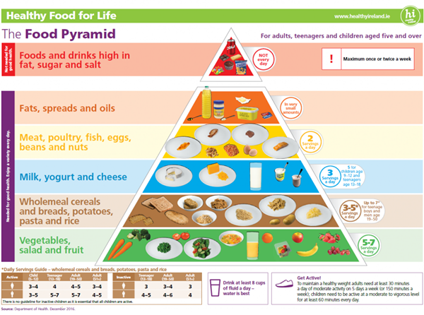

**Balance Nutrition Workshop**

**Thanks to TY student Gabriel Brozek for this article on the online Balance Nutrition TY Workshop on Tuesday 12th January 2021.**

Nutrition is of immense importance in everyday life. Nutrition is about inclusion of all food groups. Without it, the human body would lack essential materials that support its functions. That is why the TYs took part in a workshop dedicated solely to this topic. The workshop was facilitated by nutritionist, Paula Duggan, of Balance Nutrition.

Paula explained the recommended levels of sugar, protein, and carbohydrates that we should have in a healthy diet. We learned that refined carbohydrates lack the necessary nutrients to keep you going. People tend to associate diets with “minimal eating” and “increased levels of exercising”. However, as stated by Paula “a diet is not how little you eat, it is how healthy you eat.” So, we should consider adding a few berries to a bowl of porridge for that extra kick of taste and the fibre intake per berry.

Water intake is an important part of a healthy lifestyle and keeping the body moving as much as we can during the day. There are a vast variety of diets in the world. Most diets try to make people feel healthier and fitter. Some diets are followed by people due to intolerances such as lactose intolerance and celiac disease. Celiac disease is when your immunity system reacts with gluten in a negative way that can lead to digestive attacks.

Paula also gave advice on how to fully prepare your body for a sports event or match. The meals that you consume in the 2 days before the match can affect your performance. Eating poorly and not having enough sleep can cause your performance in the match to plummet. If you look after yourself, you will perform better.

We looked at recovery after the sports event or match, and the importance of rehydration, refuelling and repair. Paula reminded that of the importance of starting good habits early in life as it is difficult to change habits later in life. We would like to thank Paula for taking the time to give this talk to TYs. ***Written by, Gabriel Brozek, TY Journalist***

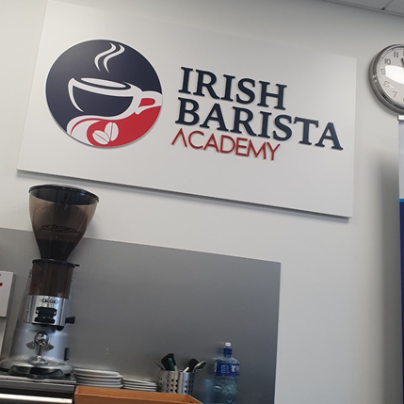

**Barista and HACCP Course**

**Thanks to TY student Bonnie Conlon, for this article on the TY Barista and HACCP Course: which 10 TYs paid for and completed just before Christmas.**

On Monday 21st of December 2020, 10 TY students took part in a course held by the Irish Barista Academy in conjunction with Excel Recruitment. The course, which took place over 6 hours in the Excel Recruitment building was divided into 2 modules. The first covered food safety, and safety in the workplace of a professional kitchen, (as well as rules and regulations) followed by a short test on the topics covered. This module provided students with a HACCP qualification that allows them to work with food. The second module covered the use of professional coffee machines and equipment, as well as how to make some popular coffees (e.g., Americano, Cappuccino, Latte, Mocha, etc.). The course provided students with a certificate to signify that they completed training as a barista.  It was great day and a great qualification to add to our CVs. It is hoped that other interested TYs will get the chance to complete this in 2021. ***Written by Bonnie Conlon, TY Journalist***

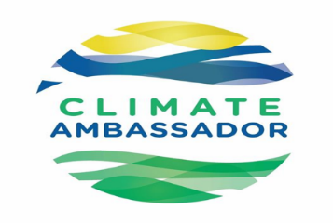**Climate Ambassadors for 2021**

ACS is delighted and proud to announce our TY Climate Ambassadors for 2021, Ava Carroll, Roisin Moss, Tom O"Hara and Jack Hand. TYs who were interested applied externally to Climate Ambassador Programme in 2020. Thanks to all TYs who applied. Best of luck to Ava, Roisin, Tom and Jack with their training and the year ahead working alongside Ms. Hughes. Keeping with the TY Theme for the Year, they will along with their Environmental Studies Team endeavor to 'be the solution'.  [#GreenSchools](https://www.facebook.com/hashtag/greenschools?__eep__=6&__cft__%5b0%5d=AZWHSoZvkvKU9WWXcFzBy6rL3dODOXSni6luMzRC6RsIBgqvQZmh3r2e5Rj4UOceIKolScmRDYyMxZipH3p4RimObpYiJG08NcFuSFBprJ_6JFUGU_EdLnPxnRnoAZpyGZm-nQUIoo8mPN85zOt4E6I3mDWf5PMPsE7cB7xEWK58qyRloiQZf7a6WzCqNUa_4Co&__tn__=*NK-R)

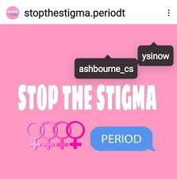

**YSI Project Meeting with Helen McEntee TD**

Thank you to Minister for Justice, Meath East TD, @helenmcentee, for attending a meeting online on Monday 1st February 2021 with TY girls from the Young Social Innovators Group, @stopthestigma.periodt. Great support and advice given. Article to follow. Well done to TY students Roisin Moss, Ava Carroll, Freya Dolan, Aoife Dunne-Carthy, Laura Moore, Katie Smith and Emily Muntean who engaged so well in the meeting. Ms Jupe, YSI Teacher and Ms Mathews, Programme Coordinator, also attended to support the girls. A lot discussed and a lot of progress made. #YSI

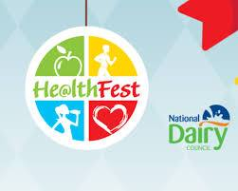

**He@lthfest 2021**

**Thanks to TY Journalist, Gabriel Brozek for this article on He@lthfest 2021 that TYs and other senior students last week.** He@lthfest 2021 was an interactive webinar that was streamed live for 2 hours on Wednesday 27th January 2021. The host was Doireann Garrihy, radio and television presenter. The Webinar had 3 segments: Healthy Body, Healthy Diet and Healthy Mind. Healthy Body included an exercise session with burpees and squats with Greg O’Shea, a known Irish Rugby union player and Love Island Winner. Next talk from the Head of Health and Human Performance in DCU, Professor Niall Moyna. He shed light on how the best exercise is the exercise which you find most enjoyable. He reminded us that exercise increases not only your physical ability, but your mental self as well. Niall worried that exercise levels in girls tend to fall during teenage years. Although they both share similarities, there are 2 types of fitness: sport and health fitness. Sport fitness is gained from sport, while health fitness you gain to improve your health, such as having a healthy heart. It is proven that 90% of the Irish healthcare budget goes towards bad health recovery. The next section was Healthy Diet with Dr Caoileann Murphy. Health and sports performance is affected by food. Only 10% of teenagers meet the recommended intake of fruits and vegetables a day, which is disturbingly low. Humans need fuelling of necessary components to keep going. Sustainable diets not only have to be sustainable, but healthy and non-harmful towards the environment. Healthy Mind is important to your development, as stated by speaker, Paul Gilligan”, Chief Executive of St. Patrick’s Mental Health Services. He noted the importance of looking after yourself and believing in yourself, are of high importance for a healthy mind. Paul Gilligan believes that this generation is more acceptant of people with mental illnesses. Dermot Whelan, comedian and presenter, stated that meditation is brilliant for reducing stress and increasing your memory capability. He recommended we try it. It was a great virtual event, and we learned a lot. ***Written by Gabriel Brozek, TY Journalist***

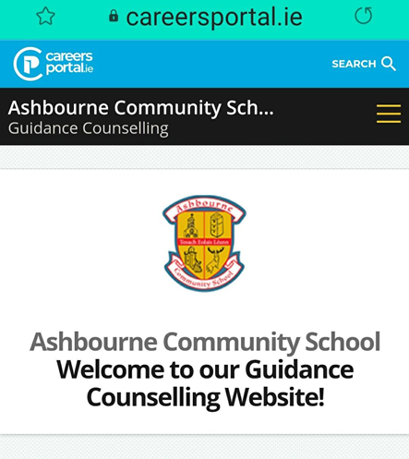

**Senior Cycle Subject Options**

**Thanks to Mia Craven, TY Journalist for this article on the first of five of the Senior Cycle Options Meetings run by the Guidance Department at ACS for TYs.**

On Tuesday 19th January 2021, TYs attended a live online class on Microsoft Teams held by our Guidance Counsellors, Ms. Rahilly and Ms. O’Neill. This meeting was the first in a number of planned meetings that will be held to help TYs make their Leaving Certificate subject choices. (Current 3rd years have had and will also have meetings). These meetings are very important because they will equip students with the information, they need to make the best decisions about subject choices for their Leaving Certificate. Students will choose their subjects by Thursday 11th March 2021. The meeting involved Ms. Rahilly recapping on EirQuest, a test that we as 3rd years took last year to identify potential careers that match our interests and aptitudes. She showed us how to navigate our results, and how to use those results to choose subjects. The PowerPoint that was shown in the meeting can be found on the Career Guidance section of the school website. We thank Mr Rahilly and Ms O‘Neill for all their help and guidance. The large variety of Leaving Certificate subjects available at ACS will be investigated in future meetings, and they will also cover the Leaving Certificate Vocational Programme and the Leaving Certificate Applied Programme.

***Written by Mia Craven, TY Journalist***



**KPMG TY Placement**

**Many companies have continued their TY Programmes virtually this year. Thanks to TY student Laura Moore for this article on her TY placement last week.**

On Monday 25th of January 2021, I attended a KPMG TY Work Experience Programme. This introduced me to what KPMG is and what work is done there. There were 60 students me included on the Zoom call. It started off with a multiple-choice quiz on facts about KPMG. Then we were separated into different breakout rooms with 6 other people where we introduced ourselves and worked together to do a fun icebreaker challenge. Next the main facilitator went through a presentation on KPMG in more detail, their values of "integrity, excellence, together and for better" and how general work life is at KPMG. They have offices based in Dublin, Belfast, Cork, and Galway and 102 business partners. A piece of information that stood out to me was a phrase they used, 'you learn from 70% hands-on work, 20% from others and 10% from training.' Later, another KPMG employee joined to educate us about the skill of presenting and how crucial it is to design a helpful PowerPoint presentation. We practiced in groups designing PowerPoints and then learned how to use shortcuts, such as pressing B on a presentation to blacken the screen, to gather the audience's attention for a moment, and many more practical skills.

After a lunch break, we discussed career opportunities in KPMG. There are many sectors in professional services such as audit, tax, deal advisory and consulting. There are also other areas such as people and operations, finance and administration, risk management and IT. Notable clients they work with are HP, Citigroup, PepsiCo, Deutsche Bank and General Electric. To wrap up the day's session we went back into breakout rooms to create a case study presentation on information we learned from that day and then presented it virtually. It was an exciting and valuable insight of a career in professional services.

***Written by Laura Moore, TY student***

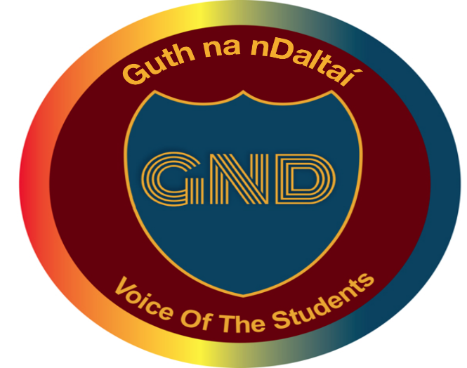



**Open Minds Science Gallery Programme**

**Thanks to TY student, Méabh Ó'Grádaigh for this article on her recent 3 day TY placement with the Science Gallery at Trinity College Dublin.**

On Monday 25th to Wednesday 27th January 2021, I attended the online OPEN MINDS Lab TY Programme with the Science Gallery at Trinity College. OPEN MIND Studio allows participants to learn and explore through workshops, talks and activities that highlight the rich network of interconnections between science, technology, and the arts. It is an opportunity to develop key competences for lifelong learning, such as problem solving, collaboration and communication. This year's OPEN MIND Studio was entitled ARTificial Intelligence Lab. As participants, we explored the impact of complex technology on modern life, as well as delving into the ethics and advances happening in artificial intelligence, and the role of bias and culture. We learned how to interpret the world around us through collaborative and interdisciplinary workshops and discussion aimed at fostering creativity and critical thinking. We looked at why we do science, explore how technology can help or harm, and delve into the role of art in understanding our place in the universe. There were 25 of us on the zoom calls over the 3 days. We regularly went into break out rooms for group discussion. We programmed AI online and had debates about ethics. The Science Gallery Dublin would also like to acknowledge the support of Intel in all our research and education outreach programmes and projects. It was a great opportunity.

***Written by Méabh Ó'Grádaigh, TY student***

**Message from Amber Flag Committee**

Boredom and stress are an extremely unpleasant combination. In these strange and unusual times humanity has found itself with a massive supply of these two things, and themselves in a world where their usual outlets have been forbidden. Our brains no longer receive the same stimuli from our daily commutes, our changes in environment, and so on. Humans are inherently social creatures, yet we are forced to, well, not. Stress levels are through the roof! We are constantly worrying about getting infected, what deadlines we have, what the Leaving Cert is going to be, what am I going to do, on and on and on. Humans are not really equipped to fully deal with stress. It is our alarm system, after all. It would be pointless if you could just turn it off That leaves one thing: Boredom.  
And boy, is that far easier to deal with.  
The first thing that most people need is a break in monotony. A change in scenery, however small, helps with this. If you work from a laptop or a phone, consider doing so in a different room occasionally. Rearrange your room if you like. Even a change in your device's wallpaper can be a new bit of information for your brain to process. Once you get the ball rolling with changes, you might find it's easier to embrace change. Learn something; how to wire a plug. Make something; up cycle an item. Do something; get out and physically active.  
  
 If you can stave off the boredom, well, that only leaves stress, which will eventually subside. Break boredom, and you will find life a lot easier.  
  
 ***Barry Kane,***

***Chairperson Amber Flag Committee***

***The final Student Newsletter of 2020 – 2021 will be published after Easter,***

***please contact the Head Students if you wish to submit an article, a piece of a Art, a quiz, poetry,…….***

***We would love to hear from you.***

