T.Y. Climate Change Project(YEA)
"Let’s get nifty with Ireland 2050"
Climate Change is one of the most important challenges facing the future of humanity. Our behavior can make a real difference. How can we highlight the challenge that climate change is once and for all?
Throughout this project, we have harnessed the power of social media. This ranges from a class room based video employing the “My 2050” video. In using this resource, we demonstrated a practical pathway to achieving an eighty percent reduction in carbon emissions by 2050. Other actions included; a student led website launch at Trinity College, along with a 2050 themed “Mannequin Challenge”, an IT based lesson to first year students and lastly an engaging collage of images, displayed on the central screen in school, identifying the reality of climate change.
The overall purpose was to impress upon our peers that urgent action is required. We all have a vital role to play in securing the future wellbeing of our planet. We believe these initiatives can help develop a collective culture of working towards a better future for our planet.
Throughout the year, we were involved in the following actions;

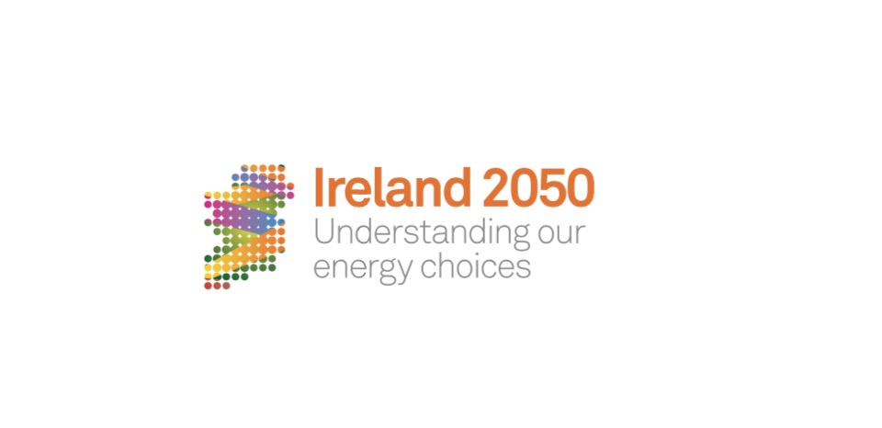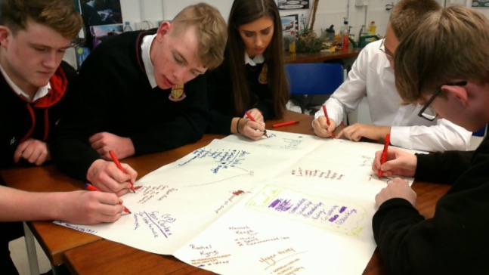
1.Lesson on Ireland 2050
Our class was selected to launch the Ireland 2050 website, David Taylor, Project manager, Sarah Stanley, Model developer and Blathnaid Tracey from RTE arrived to our classroom along with a camera crew to begin this project. They introduced us to the Ireland 2050 website http://ireland2050.ie/ . Here we given the challenge to reduce our Carbon Emissions by 80% before the year 2050. We were filmed discussing and selecting the best options for Irelands Energy Sources into the future. This video can be viewed using the link below.
https://youtu.be/d9iVUIchYL0
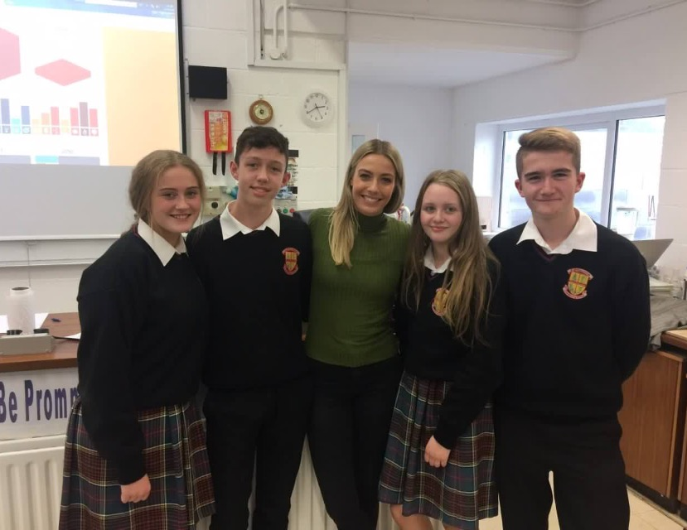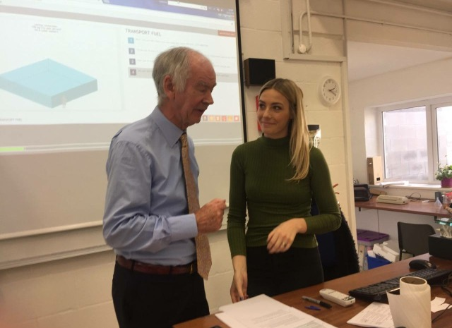

2.Website launch in Trinity College’s Science Gallery 25th October, 2016
Our class was invited to attend along with many leading Irish business representatives, politicians and the media.
The launch began with the video (as above) and continued with four of our students defending the energy choices which we had made in class, on stage to the distinguished guests.
This event brought us to national T.V, (news2day, RTE2 ) and we were featured in the Irish independent. A video of the launch can be watched at https://youtu.be/RiQ4Bv1NerA
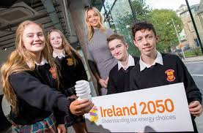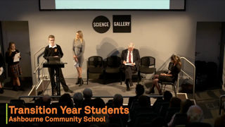

3.Mannequin challenge 20th December, 2016
Our science class decided the best way to raise awareness of the “Ireland 2050” website would be to use the mannequin trend. We made the video in the Materials Technology Wood, Home Economics and Science rooms in our school and in each room, we highlighted 'Ireland 2050' in different ways. Planning and videoing our own production was probably the most enjoyable part of the entire project.
This video can be viewed at https://youtu.be/UlGgyc-Aexs
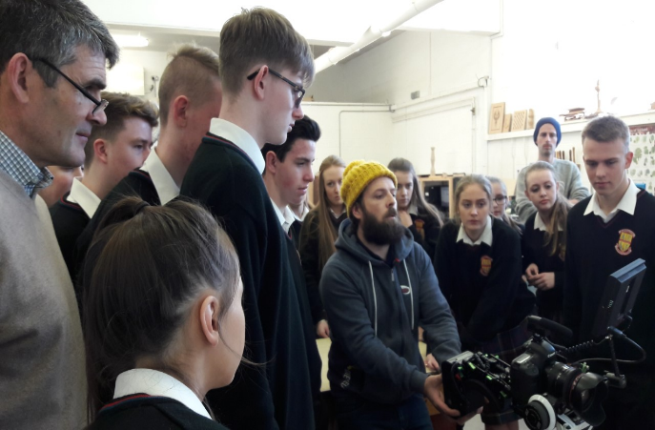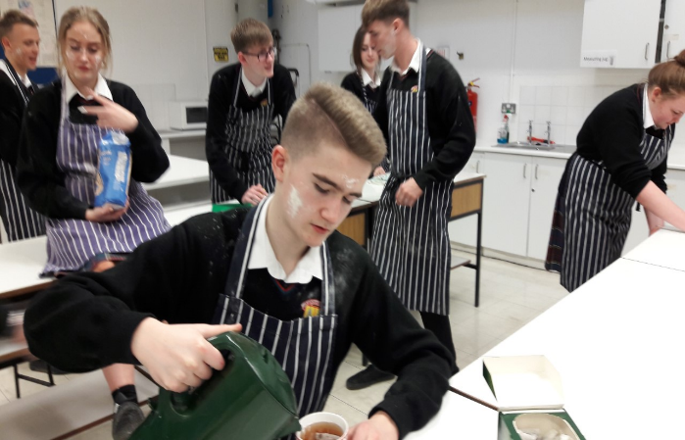

4.” Ireland 2050” Lesson
In our effort to spread awareness around the climate change issue, we decided to teach our 1st year classes how to use the “Ireland 2050” website. We made our own Kahoot (a phone based interactive quiz) based on the website. This has proven to be very popular with junior classes. The link to our Kahoot quiz is: https://play.kahoot.it/#/k/be6cad9a-dbfb-4e95-b5f3-b7fc0f7bc5ab

5.Calender of climate change images with a daily message.
In keeping with the screen based nature of this project, as a class, we prepared a calendar of screen images to be shown on the central monitor in school. They image changes daily and contains an environmental message reminding us all of our responsibility towards our planet.
A Sample of our images can be viewed below. Double click the text:
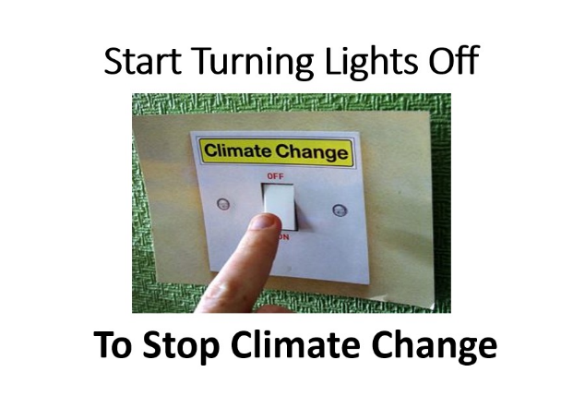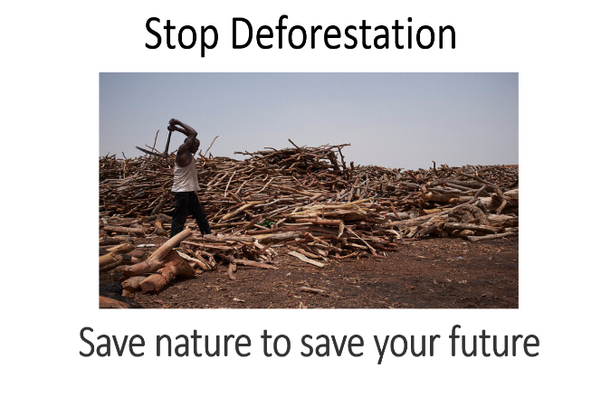
In Conclusion;
Every school year is short and our school life is busy. This is why T.Y. is such an important time and opportunity for us to appreciate what is really important to us. We are now much more aware of the immediate dangers of climate change to our generation. We have tried to use our time and skills this year to spread our concerns and message as widely as possible among our peers. We hope our actions will inspire and enable many other groups across Ireland to do their bit to protect our fragile environment.
In the word of Gandhi
"Be the change you wish to see in this world."
T.Y. Environment Class of 2016/17
